**Welcome to Holywell House Orthodontics - Nuneaton**

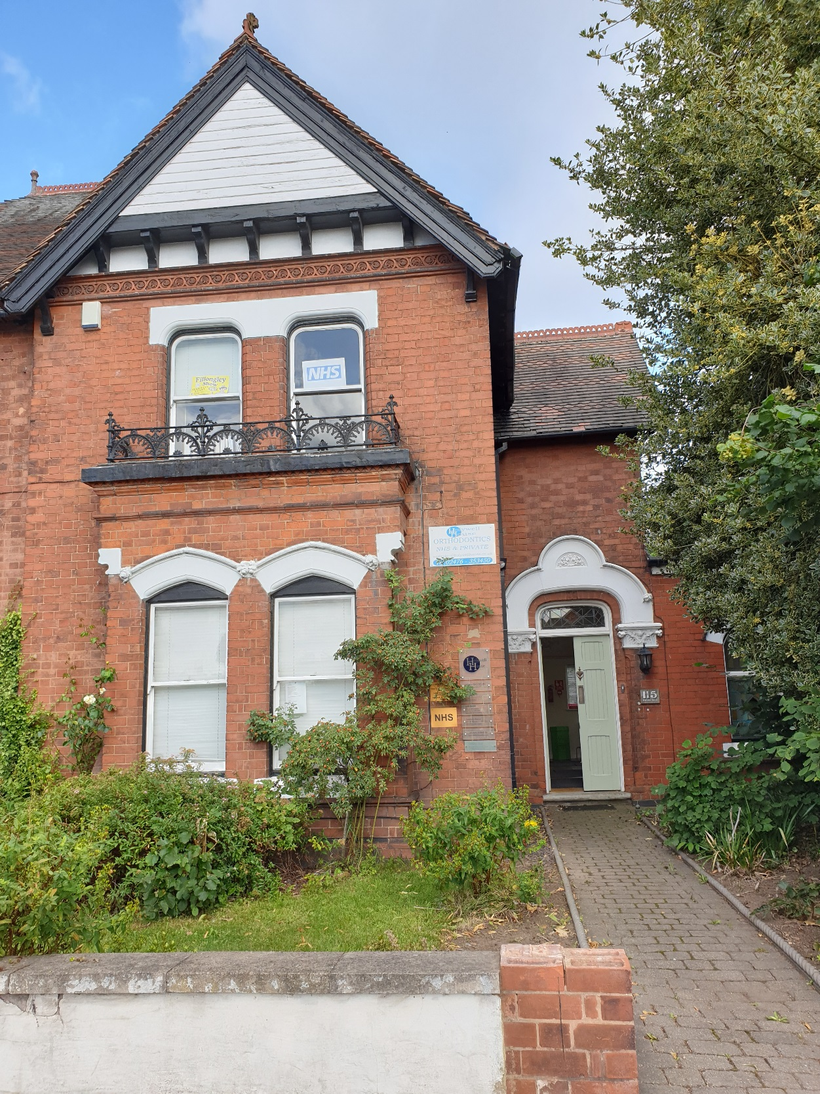

**This is our reception area….**

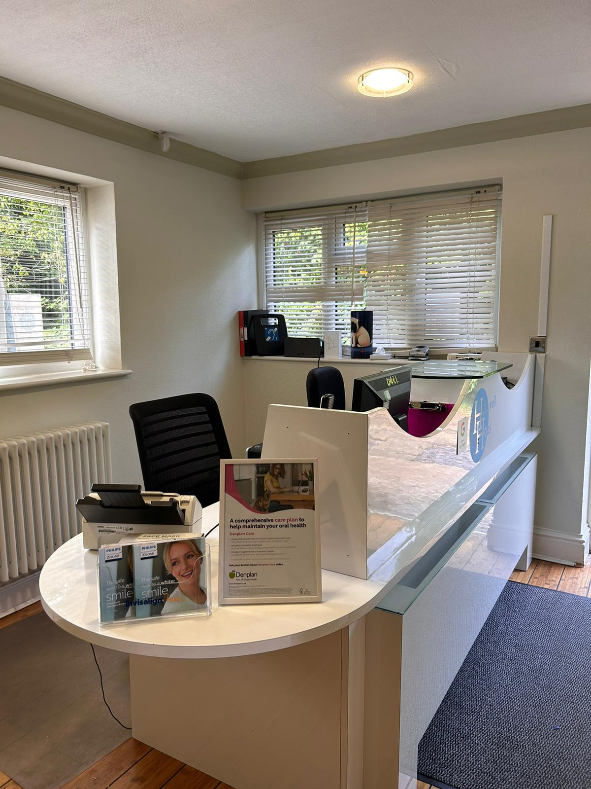

You will come here to check in for your appointment.

You will also return here to book any further appointments to see your dentist. For Orthodontic appointments we will email your next appointment out to you.

You will be greeted by friendly smiling faces.

**This is our waiting area….**

This is where you will wait for your Orthodontist or Dentist.

**This is what our dental surgery’s look like….**

There is a bright light so the Orthodontist/Dentist can see all of your teeth.

They will use a little mirror to look into your mouth.

There will be a smiling Orthodontist/ Dentist and Dental Nurse with you.

There will be mouthwash for you to rinse your teeth, or you can use plain water if you prefer.

The Orthodontist/Dentist will wear gloves and over their mouth they will wear a mask.

**Sometimes we may need to take an x-ray of your teeth, this is what our x- ray machine looks like……**

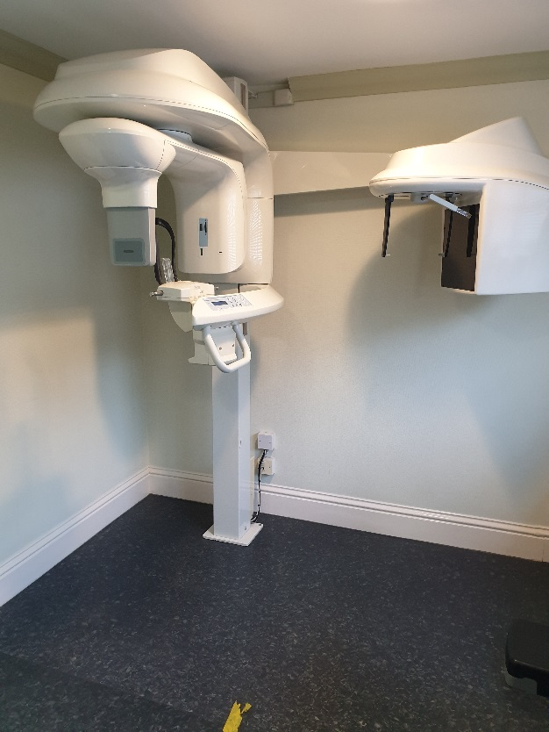

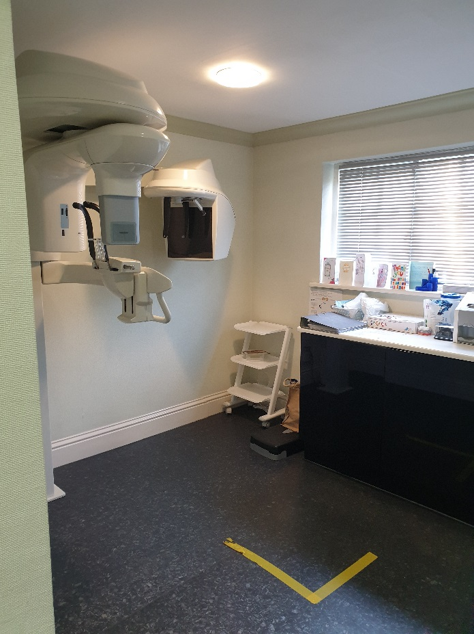

**Patient information form**

|  |  |
| --- | --- |
| **Communication:** | **Tick** |
| I prefer short specific instructions |  |
| I take longer to process verbal instructions |  |
| I may take you literally |  |
| Other |  |

|  |  |
| --- | --- |
| **Sensory difficulties:** | **Please explain** |
| Light |  |
| Sound |  |
| Touch |  |
| Smell |  |
| Other |  |

|  |  |
| --- | --- |
| **If I get upset I may…..** | **Tick** |
| Fidget more |  |
| Raise my voice/make noises |  |
| Become withdrawn |  |
| Hand flap |  |
| Other |  |

|  |  |
| --- | --- |
| **This may make me calm** | **Tick** |
| Talk slower using less words |  |
| Let me have a break |  |
| Don’t touch – stop what you are doing |  |
| Other |  |

|  |  |
| --- | --- |
| **Appointment time preference** | **Tick** |
| Morning |  |
| Afternoon |  |

**Communication Passport**

Hello my name is:

|  |
| --- |
| I like…. |

|  |
| --- |
| I don’t like…. |

|  |
| --- |
| I get angry when…. |

|  |
| --- |
| I’m happiest when…… |

|  |
| --- |
| These things are important to know…. |

If you have any questions or if you would like any further advice, please don’t hesitate to give us a call or pop into the practice.

If you speak to either Maree Roper (Reception Manager) or Liz Wiggins (Dental Nurse) they will be able to help and give you any reassurance you need.